Bradford Assay with Pierce™ Bradford Protein Assay Kit
Pierce™ Bradford Protein Assay Kit 950 mL | Buy Online | Thermo Scientific™

Standard solutions:
- From the Albumin (BSA) stock solution, the following standard solutions should be prepared for the working range of 100-1500 µg/mL
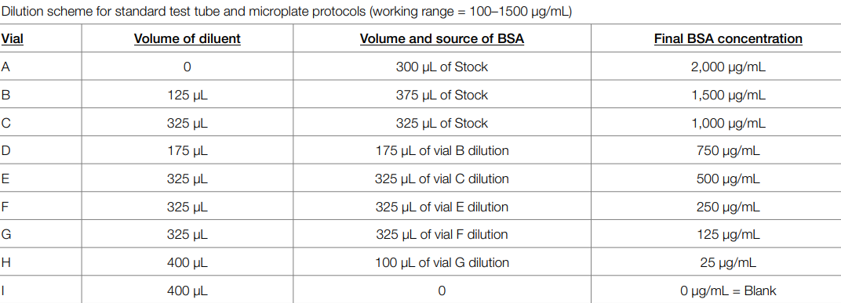

- From those stock solutions, make a 1:5 dilution (e.g. 10 µL standard stock to 40 µL of dH20) as working solution

Standard 96-well plate protocol:
Work under the fume hood and wear gloves
- Dilute Coomassie Bradford Protein Assay Reagent (stored at 4°C in the fridge) 1:5 with dH20 (e.g. 3 mL Coomassie Bradford Protein Assay Reagent plus 12 mL dH20; 250 µL Coomassie Bradford Protein Assay Reagent dilution needed per sample)
  - Take the amount of Coomassie Bradford Protein Assay Reagent you need, bring to room temperature and then add dH20, gently mix
- Pipette 5 µL of each standard or unknown protein sample into the respective well, then add 250 µL of Coomassie Bradford Protein Assay Reagent dilution to each well
- Mix by gentle pipettting
- Incubate for 10 min at room temperature
- Measure absorbance at 595 nm with the plate reader (2nd floor)
  - Spectrophotometer: Molecular Devices, Spectra max PLUS needs to be booked via ClusterMarket
  - Select method with shaking before absorbance measurement
- Substract average absorbance at 595 nm for the blanks of all other standards or unknown protein samples
- Calculate standard curve by plotting average blank-corrected 595 nm measurement for each BSA standard vs its concentration in µg/mL; use this to determine the protein concentration of each sample

96-well plate:
 | 1 | 2 | 3 | 4 | 5 | 6 | 7 | 8 | 9 | 10 | 11 | 12
A | A | B | C | D | E | F | G | H
B | A | B | C | D | E | F | G | H
C | A | B | C | D | E | F | G | H
D
E
F
G
H

