CLONING MANUAL VAN DE POEL LAB
CLONING MANUAL VAN DE POEL LAB 1
DNA extraction 2
gDNA extraction from Arabidopsis for cloning 2
Rough gDNA extraction from Arabidopsis, Marchantia or Physcomitrium for quick genotyping 2
DNA synthesis 3
Plasmid miniprep 3
Freezer stocks 4
PCR on DNA template 5
PCR clean-up 6
GeneJET PCR Purification Kit 6
Isopropanol method 7
Gel extraction with a kit 8
Low melting agarose gel extraction 9
Agarose gel electrophoresis 9
Restriction enzyme digestion 10
Ligation 11
T4 ligation 11
Restriction-based cloning 11
Gateway cloning 12
GreenGate cloning 16
Multiple transcriptional units 19
Gibson cloning 20
Gibson primer design 20
Gibson reaction 21
Site directed mutagenesis (SDM) 22
Escherichia coli transformation 26
Agrobacterium tumefaciens transformation 27
Making competent cells 28
Colony PCR 30
Sequencing (Sanger) 31
Antibiotics 32

DNA extraction

gDNA extraction from Arabidopsis for cloning
Extraction buffer:
- 200 mM Tris-HCl pH 7.5
- 250 mM NaCl
- 25 mM EDTA
- 0.5 % SDS

Protocol:
- Grow up desired genotype and take a small bit of plant material (e.g. ~ 50 mg of leaf) in a 1.5 mL ep.
- Flash-freeze in liquid nitrogen.
- First slightly crush with a sterile pestle (bleu), then add 400 µL of the extraction buffer and ground completely to fine powder with the pestle.
- Centrifuge at maximum speed for 1 minute at 4°C.
- Take ± 350 µL of the supernatant and transfer to a new tube.
- Add 1:1 cold isopropanol (100 %) and mix thoroughly.
- Leave overnight at -20°C.
- Centrifuge at 4 °C at maximum speed for 2 minutes and discard the supernatant.
- Add ± 600 µl cold EtOH (70%).
- Centrifuge again at 4°C at maximum speed for 2 minutes and discard the supernatant, be careful not to disturb the pellet.
- Keep the tubes open to dry the pellets and remove all the EtOH (around 10 minutes) at room temperature.
- Resuspend in ± 20 µL MilliQ

Rough gDNA extraction from Arabidopsis, Marchantia or Physcomitrium for quick genotyping
Solutions (both from sigmaaldrich.com):

- (Extract-N-Amp Direct PCR Extraction Solution)
- Dilution solution D5688-12mL (Dilution Solution, Plant Direct PCR Sigma-Aldrich)
Both solutions were originally intended to be used for the Extract-N-Amp Plant PCR kit (sigmaaldrich.com). However, a modified version of the manufacturer's protocol can be used to prep gDNA from different plant species for genotyping (up to 1000 bp fragments) and can be tested to be used for cloning (quality might not be good enough for difficult PCR amplifications or downstream cloning).
Protocol:
- Aliquot 15-30 µL of extraction solution into a PCR tube
- Transfer a small piece of plant material into the tube (for Arabidopsis: small leaf from seedlings or a piece of a leaf from older plants; for Marchantia or Physcomitrium: small piece of plant material)
The plant material should not soak up all the extraction solution present in the tube; therefore, avoid taking too much plant material, but also not too little
- Incubate the samples for 10 min at 90 °C in a thermocycler
- Add an equal amount of dilution solution (15-30 µL; 1:1 ratio of extraction to dilution solution)
- Mix by pipetting up and down or by vortexing
- Now, the gDNA is ready to be used for PCR
For genotyping (and subsequent sequencing): if a PCR volume of 50 µL is used, 4 µL of the gDNA should is recommended

DNA synthesis
Synthetic genes:
Currently, GenScript offers the best price for synthetic genes with the FLASH Gene service (https://www.genscript.com/flashgene.html?src=mostpopular&_gl=1*ukytz3*_up*MQ..*_gs*MQ..&gclid=Cj0KCQiAhbi8BhDIARIsAJLOludj2Q72zXIRsI9vPCXn7awQ4I4rnsdqDoHuMy-nKzqm0efSu1DQEVoaAkstEALw_wcB)
Do not set-up an account directly; ask for an official recommendation from a colleague via the GenScript webpage, this will allow you to get some further discount for your quote
(If the prices change in the future, alternative companies could be: TwistBioscience or BioCat)
Codon optimisation
For ordering primers, oligos and gene fragments, IDT can be used (https://www.idtdna.com.).
Primers are ordered as “Single-stranded DNA” in tubes, generally at a concentration of 25 nmole DNA.

Plasmid miniprep
Execute all steps at room temperature. We use the Thermo Scientific GeneJJET Plasmid Miniprep kit (K0502).
Before you start:
- Check if the Resuspension solution contains RNase A and is stored in at 4 °C and is not older than 6 months.
- Check if ethanol (96 %) is added to the Wash solution (in a ratio 1:1.75 or 35 mL EtOH per 20 mL Wash solution)
- Check if there are salt precipitates or not. If so, shake the bottle or heat it up to 37 °C, and let it cool down again to room temperature.
- In case you are making a freezer stock, take out an aliquot from your overnight culture before doing the mini-prep.
- Always make sure the bag of spin columns is airtight closed before and after use.
Protocol:
- Harvest overnight culture of 5 mL in a falcon, or take a 2 mL ep tube and centrifuge at 8000 rpm (6800 x g) for 2 min at room temperature.
  - To increase plasmid yield for low-copy numbers: take 2 or 3 x 2 mL culture (or spin down 10 mL culture in a falcon) and pool them after the resuspension step.
- Remover the supernatant by pipetting or decanting (make sure the LB medium is gone).
- Resuspend the pellet in 250 uL Resuspension Solution by briefly vortexing the cells and the pellet is completely dissolved.
  - If you have multiple pellets from the same culture, only use 250 uL Resuspension Solution once for all pellets.
- Add 250 uL Lysis buffer and mix immediately by thoroughly inverting the tubes 4-6 times (do not vortex) until the solution becomes viscous and clear.
- Add 350 uL Neutralization Solution and mix immediately by thoroughly inverting the tube 4-6 times (do not vortex)
- Centrifuge for 5 min at >12.000 x g at room temperature.
- Transfer the supernatant to the GeneJET spin column by decanting or pipetting.
- Centrifuge the spin columns for 1 min at >12.000 x g at room temperature.
- Add 500 uL Wash Solution to the GeneJET spin column.
- Centrifuge the spin column for 1 min at >12.000 x g at room temperature.
- Discart the supernatants and reuse the collection tube.
- Centrifuge the spin column for an additional 1 min at >12.000 x g at room temperature.
- Make sure no ethanol residues remain or touch the spin column.
- Transfer the spin column to a new collection tube (or 1.5 mL ep).
- Add 50 uL Elution Buffer (or Mili-Q water) to the spin column membrane (in the center).
- Do not touch the spin column membrane with the pipette tip.
- You can also lower the elution volume to 25 uL to increase the plasmid concentration.
- Incubate the spin column for 2 min at room temperature.
- Centrifuge the spin column for 2 min at > 12.000 x g at room temperature.
  - You can resuspend the flow-through containing the plasmid on the same spin column membrane and repeat steps the last two steps to get a slightly higher plasmid yield.
- Store the plasmid at -20 °C.

Freezer stocks
- Take 0.75 mL of overnight bacterial culture and pipet in an autoclaved 1.5 mL screw-cap tube.
- Add 0.75 mL of 25 % Glycerol (v:v in water).
The final glycerol concentration should be 12.5 %.
- Write down the plasmid name, date, E coli strain and your name on the tube using a cryo-marker.
- Store in the -80 °C freezer and update the inventory list.

PCR on DNA template
For cloning, high fidelity DNA polymerases such as Q5 and Phusion are used.
- Reaction Setup for Phusion Polymerase:
All components should be mixed and centrifuged prior to use.
Assemble all reaction components on ice and quickly transfer the reactions to a thermocycler preheated to the denaturation temperature (98°C).
Add the DNA Polymerase last to prevent any primer degradation caused by the 3´→ 5´ exonuclease activity.
Component | 20 µL Reaction | 50 µL Reaction | Final Concentration
Nuclease-free water | to 20 µL | to 50 µL
5 X Phusion HF or GC Buffer | 4 µL | 10 µL | 1 X
10 mM dNTPs | 0.4 µL | 1 µL | 200 µM
10 µM Forward Primer | 1 µL | 2.5 µL | 0.5 µM
10 µM Reverse Primer | 1 µL | 2.5 µL | 0.5 µM
Template DNA | Variable  (see below) | Variable  (see below) | < 250 ng
DMSO (optional) | (0.6 µL) | (1.5 µL) | 3 %
Phusion DNA  Polymerase | 0.2 µL | 0.5 µL | 1.0 units/50 µL PCR

To determine the amount of template DNA:
DNA | Amount
Genomic | 50 ng–250 ng
plasmid or viral | 1 pg–10 ng
Note: do not use more DNA/plasmid template as indicated: too much template can consume all primers.
- Thermocycling conditions for a routine PCR:
Step |  | T [°C] | Time
Initial Denaturation |  | 98°C | 30 seconds
25-35 Cycles | Denaturation | 98°C | 5-10 seconds
25-35 Cycles | Annealing | T_{annealing} of the primers (45-72°C) | 10-30 seconds
25-35 Cycles | Elongation | 72°C | Depending on the length of the amplicon  for Phusion: 15-30s/kb
 | Final extension | 72°C | 5-10 minutes
 | Hold | 4-10°C

Trouble shooting
- GC buffer: replace the HF buffer with the GC buffer for DNA amplicons that have a high GC content (65-80 % GC content).
- DMSO can be added: it lowers the melting temperature and prevents annealing, thereby minimizing secondary DNA structures which can increase the specificity.
- Gradient PCR: make a gradient in the PCR machine to test different annealing temperatures. Sometimes primers work better at a lower or higher temperature as the theoretical best temperature.
- Quick-step PCR: try omitting the annealing step in the PCR program if the annealing temperature of the primers is too high (>68 °C). Just run your sample by cycling between the denaturing (98°C) and extension (72°C) step.
- Touch-down PCR: increasing specificity of PCR reactions (less nonspecific amplification) by starting with a higher annealing temperature and gradually reducing it through e.g. 10 cycles until it reaches the calculated annealing temperature of the primers or some degrees below.
Follow the standard Reaction Setup for PCRs
Thermocycling conditions:
Step |  | T [°C] | Time
Initial Denaturation |  | 98°C | 30 seconds
10 Cycles  Auto delta:  -0.5°C | Denaturation | 98°C | 5-10 seconds
10 Cycles  Auto delta:  -0.5°C | Annealing | T_{annealing} + 2°C | 10-30 seconds
10 Cycles  Auto delta:  -0.5°C | Elongation | 72°C | Depending on the length of the amplicon  for Phusion: 15-30s/kb
10 Cycles  Auto delta:  -0.5°C | Denaturation | 98°C | 5-10 seconds
25 Cycles | Annealing | T_{annealing} – 3°C | 10-30 seconds
25 Cycles | Elongation | 72°C | Depending on the length of the amplicon  for Phusion: 15-30s/kb
25 Cycles | Final extension | 72°C | 5-10 minutes
 | Hold | 4-10°C

PCR clean-up

GeneJET PCR Purification Kit
All purification steps should be carried out at room temperature.
All centrifugations should be carried out in a table-top microcentrifuge at >12000 x g
- Add a 1:1 volume of Binding Buffer to completed PCR mixture and mix thoroughly by pipetting up and down.
(Color should be yellow. If the color of the solution is orange or violet, add 10 μL of 3 M sodium acetate, pH 5.2 solution and mix.)
  - Optional: if the DNA fragment is ≤ 500 bp, add a 1:2 volume of 100 % isopropanol (e.g., 100 μL of isopropanol should be added to 100 μL of PCR mixture combined with 100 μL of Binding Buffer). Mix thoroughly.
Note. If PCR mixture contains primer-dimers, purification without isopropanol is recommended. However, the yield of the target DNA fragment will be lower.
- Transfer ≤ 800 μL of the solution from step 1 to the GeneJET purification column.
- Centrifuge for 30-60 s at >12000 x g at room temperature and discard the flow-through.
  - Repeat this step, until the entire solution has been added to the column.
- Add 700 μL of Wash Buffer to the purification column.
Check if the Wash buffer was diluted with ethanol before use.
- Centrifuge for 30-60 s at >12000 x g at room temperature and discard the flow-through and place the purification column back into the same collection tube.
- Centrifuge the empty GeneJET purification column for an additional 1 min at >12000 x g at room temperature to completely remove any residual wash buffer.
- Transfer the GeneJET purification column to a clean 1.5 mL microcentrifuge tube.
- Add 50 μL of Elution Buffer or Milli-Q to the center of the GeneJET purification column membrane and centrifuge for 1 min.
  - Note. For low DNA amounts the elution volumes can be reduced to a volume between20-50 μL.
  - If DNA fragment is >10 kb, prewarm Elution Buffer to 65 °C before applying to column.
  - You can resuspend the flow-through containing the plasmid on the same spin column membrane and repeat steps the last two steps to get a slightly higher plasmid yield.
- Discard the GeneJET purification column and store the purified DNA at -20 °C.

Isopropanol method
Extraction buffer:
- 200 mM Tris-HCl pH 7.5
- 250 mM NaCl
- 25 mM EDTA
- 0.5 % SDS

Protocol:
- add 400 µL of cold extraction buffer to your DNA sample.
- Centrifuge at maximum speed for 1 minute at 4°C.
- Take ± 350 µL of the supernatant and transfer to a new tube.
- Add 1:1 cold isopropanol (100 %) and mix thoroughly.
- Leave overnight at 4°C.
- Centrifuge at 4 °C at maximum speed for 2 minutes and discard the supernatant.
- Add ± 600 µl cold EtOH (70%).
- Centrifuge again at 4°C at maximum speed for 2 minutes and discard the supernatant, be careful not to disturb the pellet.
- Keep the tubes open to dry the pellets and remove all the EtOH (around 10 minutes) at room temperature.
- Resuspend in ± 20 µL MilliQ

Gel extraction with a kit
E.Z.N.A Gel Extraction Kit (Omega Bio-tek)
Before starting:
- Prepare SPW Buffer according to the manual (add 100 % ethanol)
- Set heating block or water bath to 60 °C
- Decontaminate the UV-illuminator with ethanol.
- Wear protective eyewear when using the UV-illuminator.

- After adequate separation of bands in an agarose gel, carefully excise the DNA fragment of interest with a decontaminated scalpel or razor blade.
- Take the minimum size of agarose slice as possible (flip the excised band and remove the bottom part of the agarose that does not contain DNA).
- Chop the agarose slice into smaller pieces.
- Weight the agarose slice in a clean 1.5 mL reaction tube.
- Add 1 volume XP2 Binding Buffer (volume of XP2 buffer in mL = weight of agarose in mg).
- Incubate at 60 °C for 7 min or until completely melted; vortex/shake the tube every 2-3 minutes.
  - Monitor the pH of Gel/Binding Buffer mixture by color (if it turns orange/red, add 5 µM sodium acetate pH 5.2).
- Add up to 700 µL of the Gel/XP2 Binding Buffer solution to a HiBind DNA Mini Column inserted into a 2 mL Collection Tube
- Centrifuge at 10,000 x g for 1 minute at room temperature, discard the flow-through
- Repeat these last two steps until all of the Gel/XP2 Binding solution has been transferred to the column
- Add 300 µL XP2 Binding Buffer
- Centrifuge at 13,000 x g for 1 minute at room temperature, discard the flow-through
- Add 700 µL SPW Buffer
  - Check if SPW Buffer is diluted with 100 % ethanol prior use
- Centrifuge at 13,000 x g for 1 minute at room temperature, discard flow-through
- Repeat the washing step with SPW Buffer
- Centrifuge the empty Column at 13,000 x g for 2 minutes at room temperature to dry the column
- Transfer the Column to a clean 1.5 mL reaction tube
- Add 30-50 µL Elution Buffer or Mili-Q water to the center of the column membrane (do not touch the membrane with your pipette tip).
  - To increase the DNA yield, preheat the Elution buffer or Mili-Q water to 65 °C
- Incubate for 2 minutes at room temperature.
- Centrifuge at 13,000 x g for 1 minute at room temperature
  - To increase the DNA yield: repeat the last 3 steps by re-suspending the same DNA elution fraction onto the same column membrane
- Store DNA at -20 °C.

Low melting agarose gel extraction

Agarose gel electrophoresis
1 x TAE running buffer recipe can be diluted from a 50 X TAE stock solution with pH around 8.5:
50 X TAE stock | For 1 L | Final concentration
Tris-buffer (121.14 g/mol) | 242 g | 2 M
0.5 M EDTA stock solution (pH 8) | 100 mL | 50 mM
Acetic acid 100 % | 57.1 mL | 1 M
Note: 0.5 M EDTA is store-bought (do not attempt making this yourself). The 50 x TAE buffer is stored at room temperature. pH should not be adjusted normally.
- DNA gel electrophoresis
  - Weight out the appropriate mass of agarose into an Erlenmeyer flask. Agarose gels are prepared using a w/v percentage solution. The concentration of agarose in a gel will depend on the sizes of the DNA fragments to be separated, with most gels ranging between 0.5 %-2 %.
    - For several general approaches in our lab, a 1 % gel is appropriate
    - For small DNA fragments (< 750 bp), try using a higher % (e.g. 2 %)
    - For separating large DNA fragments (> 5.000 bp), try using a lower % (e.g. 0.8 %)
  - Add running buffer to the agarose (1 X TAE) inside the Erlenmeyer flask
    - Use around 30 mL for small gels
    - Use around 60 mL for medium gels
    - Use around 80 mL for large gels (two layers of combs)
  - Melt the agarose/buffer mixture in the microwave, make sure that the mixture is sufficiently dissolved (it can boil in the microwave)
  - Pour the mixture into a prepared gel holder including the gel comb and add a droplet (1-2 µL) of Ethidium Bromide, mix thoroughly using the pipet tip
    - BE CAREFUL not to touch anything with your hands after working in the EtBr contaminated area! Always wear gloves when working with EtBr.
    - Remove air bubbles attached to the comb wells
    - Make sure to have a tray underneath in case of spilling gel
  - After solidification (30 min), place the gel into a gel chamber supplied with enough 1 x TAE running buffer
    - Note: during warm summer days, gel solidification can take longer.
  - Gently remove the comb by lifting it upwards
  - Load your samples
    - Samples contain loading dye to a 1 X end concentration
  - Load a DNA ladder (e.g. 10 Kb-ladder: 4.5 µL, at one or both sides of your sample)
  - Run the gel at manual settings (steady 120 V) for about 30-40 min or until your DNA is separated sufficiently
  - Visualize the gel at the Biorad GelDoc Gel Imaging System

- RNA gel electrophoresis
Note: RNA is easily degraded by RNases which are omnipresent in the gel tank or the buffers. Also use filter tips to prevent aerosols being blown in your samples. Make sure all products are clean by rinsing them with RNase-AWAY. Wear gloves at all times.
  - RNA gels are prepared similarly to DNA gels (1 % agarose), however, due to the instability of RNA, the devices (holders, combs, gel tank) should be cleaned with RNase AWAY prior use
  - The running buffer (1 x TAE) is separate for RNA-gels (do not use same running buffer as for DNA gels)
  - Prepare the gel as mentioned above with 1X TAE electrophoresis buffer diluted with DEPC H₂O; do not use this buffer again.
  - Add loading dye to your samples prior loading them on the gel
  - Add the normal DNA ladder
  - Running conditions and visualization are identical as for DNA gels as indicated above

Restriction enzyme digestion
A full list of restriction enzymes available in the PLT lab can be found in “Documents - BIOSYST - Van de Poel Lab/PPL-Lists/Restricton enzymes PPL.xlsx”
A typical restriction digest using ThermoFisherScientific restriction enzymes:
dH₂O | Up to 20 µL
10X Buffer | 2 µL (1X)
DNA | Up to 1 µg
Restriction Enzyme (10 units) | 1 µL each
Mix gently and gently spin down for a few seconds.
Note: the restriction enzyme should be the last added to the reaction and always kept on ice
- If you use several enzymes at once, the amount of enzymes should not exceed 1/10 of the total reaction volume
- If you use several enzymes at once, check for their efficiency in the diverse buffers (FD/B/G/O/R/Tango; Reaction Conditions for Restriction Enzymes | Thermo Fisher Scientific - BE)
- Incubation time can be 1-16 hours, typically 1-4 hours, but can be increased up to 16 hours with reduced units
  - Longer incubation times are needed when buffer compatibility is not optimal.
- Incubation temperature is enzyme-dependent, typically at 37 °C
- Stopping the digestion reaction might be done by heat inactivation (65 °C or 80 °C for 20 minutes, depending on the enzyme)

Ligation

T4 ligation
- Set up the following reaction in a pcr-tube on ice
Component | 20 μL Reaction
T4 DNA Ligase Buffer (10X)* | 2 μL
Vector DNA (50 ng) | Use NEBioCalculator to calculate molar ratios
Insert DNA | Use NEBioCalculator to calculate molar ratios
Nuclease-free water | to 20 μL
T4 DNA Ligase | 1 μL
Note: You can easily scale down the reaction to 10 uL..

T4 DNA Ligase should be added last.
T4 DNA Ligase Buffer should be thawed and resuspended at room temperature.

It is recommended to start with 3:1 insert:vector ratio and if unsuccessful to repeat with 1:1 and 5:1.

- Gently mix the reaction by pipetting up and down and briefly spin down.
- Incubate in a PCR machine:
  - For cohesive (sticky) ends, incubate at 16 °C overnight or room temperature for 10 minutes.
  - For blunt ends or single base overhangs, incubate at 16 °C overnight or room temperature for 2 hours.
(high concentration T4 DNA Ligase can be used in a 10 minute ligation).
  - Alternatively incubate at room temperature for 2 hours, followed by incubation at 16°C overnight.
- Heat-inactivate at 65 °C for 10 minutes.
- Chill on ice and transform 1-5 μl of the reaction into 50 μL competent cells.

Restriction-based cloning
This is a classical method by combining the unique cut-sites of two different restriction enzymes to clone in a DNA fragment in the vector of choice. The RE cut-sites for a PCR product are typically added to the primers (extra base pairs after the template specific primer part).
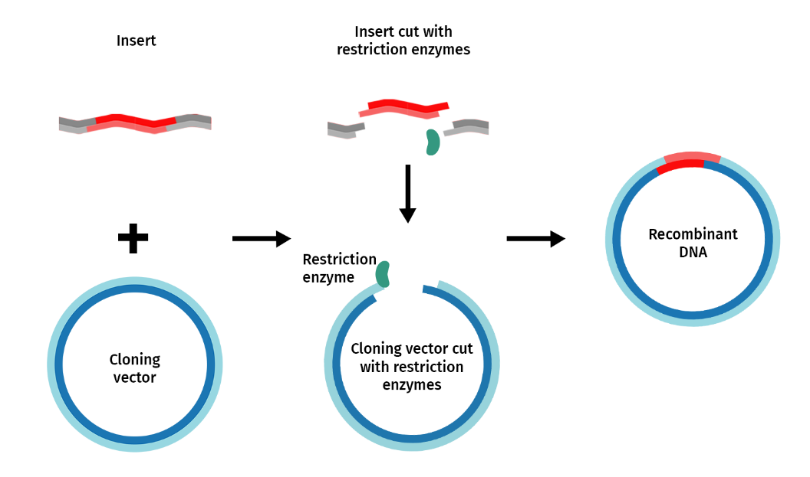
- Choose your backbone and insert so that they have compatible RE cut sites for restriction enzymes that allow your insert to be placed into the backbone in the proper orientation.
Note: take into account the orientation of the insert in your vector.
- Depending on the restriction sites available in the backbone, add the corresponding sites to the start and end of the insert through PCR
Note: make sure these restriction sites are unique to the sites you need, avoid internal cut sites in both the vector and insert. In the case the RE can cut in your template, either use other RE or perform site directed mutagenesis.
- Digest both backbone and insert with the correct RE(s) in separate reactions (see restriction digest)
  - The restricted insert can be isolated by using a PCR purification kit (see PCR clean-up)
  - The restricted vector backbone will have to be gel extracted, therefore it is recommended to use 1 µg of DNA template for its digestion
Note: If you are going to use only one restriction enzyme for both ends, or enzymes that have compatible overhangs or no overhangs after digestion, you will need to use a phosphatase to prevent re-circularization of the backbone plasmid. Therefore, treat the vector with a phosphatase after RE digestion and prior to the ligation step (or prior to the gel purification step). CIP (calf alkaline phosphatase) or SAP (shrimp alkaline phosphatase) are commonly used phosphatases.
- Ligate the two fragments with T4 DNA ligase (see ligation)
- After transforming and miniprepping the plasmid, use sequencing primers that cover the backbone and insert to confirm correctness of the orientation of the insert

Gateway cloning
Official protocol for multiple Gateway cloning:
https://www.thermofisher.com/be/en/home/life-science/cloning/gateway-cloning.html
The protocol is described for cloning a promotor and gene of interest using two entry vectors: pDONRP4P1 for the promotor and pDONR221/pDONR207 for the coding sequence (CDS)
Primer design for cloning of promoter in pDONRP4P1:
- Select a promoter region about around 3 Kb
- For the design of the primers, select DNA-specific sequences of 18-25 bp each and add Gateway-specific sequences
- For promoter cloning, the attB4/B1r sites are compatible with pDONRP4-P1R
- Gateway attachment sites plus 18-25 bp sequencing-specific (indicated with “X”)
attB4-Promoter-F | GGGGACAACTTTGTATAGAAAAGTTGxxxxxxxxxxxxxxxxxxxx
attB1r-Promoter-R | GGGGACTGCTTTTTTGTACAAACTTGxxxxxxxxxxxxxxxxxxxx

Note: the reverse primer should stop right before the ATG start site of the CDS.
Note: in some cases, there are regulatory elements in the first intron of the gene, and in this case, you include the first intron in the sequence of the promotor. Make sure the start site is non-functional, so that the actual start site is in the fusion protein.
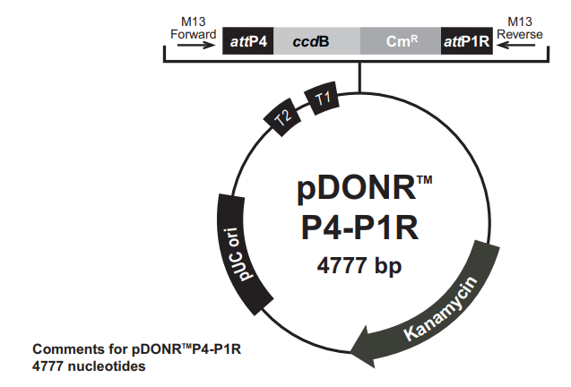

Primer design for cloning of coding sequences in pDONR221 or pDONR207:
- Use cDNA (and not gDNA) for PCR-amplifying the gene of interest.
- For cloning a gene of interest via the Gateway cloning strategy, design primers consisting of 18-25 bp gene-specific sequences and the Gateway attachment sites.
- The attB1/2 sites are compatible with pDONR221 or pDONR207 as entry vector
- For the gene-specific sequences:
  - The forward primer starts with the start codon (ATG) of the CDS
  - For the reverse primer, it depends if you want to add a C-terminal tag (e.g. fluorescent marker like GFP)
    - If you have no tag at the end of the gene: you include the stop codon in the sequence-specific part of your primer.
    - If you want to add a C-terminal tag, then do not include the stop codon in the sequence-specific part of your primer, and make sure the coding sequence is in frame with the C-terminal tag in the destination vector.
attB1-CDS-F | GGGGACAAGTTTGTACAAAAAAGCAGGCTTCatgxxxxxxxxxxxx
attB2-CDS-R | GGGGACCACTTTGTACAAGAAAGCTGGGTCxxxxxxxxxxxxxx
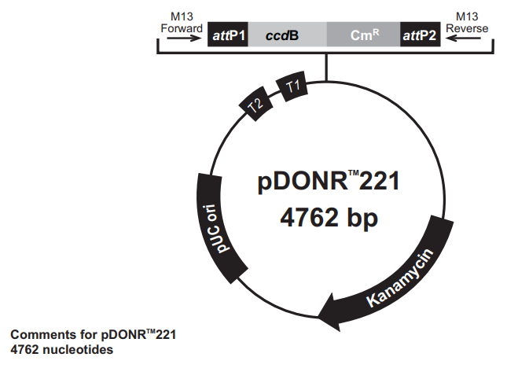

Before starting:
- For the BP and LR reactions, half the enzyme volume of the official protocol is sufficient (4 µL instead of 8 µL)
- Aliquot the BP and LR clonase enzyme mix and avoid freezing and thawing; prepare aliquots of about 2 µL, and store at -80 °C as this increases the lifespan of the enzymes.
- Treat the BP and LR clonase enzyme mix gently; do not vortex!

- BP reaction (Gateway™ BP Clonase™ II Enzyme mix):
  - Put 150 ng entry vector (e.g. pDONR221 or pDONR227 or pDONRP4P1) in a PCR tube.
  - Add attB-PCR product (40-100 fmol)
    - Optional use a pDEST with GOI already including attB-sites in the same amount as the pDONR
  - Add 2 µL TE buffer pH 8.0 (10 mM Tris-HCl, 1 mM EDTA, pH 8.0)
    - Use at least 2 µL TE buffer; fill up to 4 µL with TE buffer if needed.
  - Add 0.5-1 µL BP clonase enzyme
    - for small inserts like oligo cloning, 0.5 µL BP clonase is sufficient; for longer sequences like promoter regions or coding sequences use 1 µL
    - Add BP clonase gently (do not vortex), flick against the tube and then gently spin down the mixture quickly
  - Incubate mixture at 25 °C for at least 1 h (preferably overnight) in a PCR machine.
    - Reaction mixture can be also kept at room temperature (instead of 25 °C), unless the room temperature is unusually high or low (winter/summer)
- Optional: Add 0.5 µL of Proteinase K solution to terminate the reaction; incubate for 10 min at 37°C *works also without proteinase K treatment
For calculating the fmol PCR-product needed for the BP reaction, use the following formula:
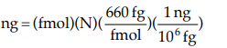- N: size of DNA in bp
For further details see: https://assets.thermofisher.com/TFSAssets/LSG/manuals/gateway_clonaseii_man.pdf
- LR reaction (Gateway™ LR Clonase™ II Enzyme mix):
  - Put 150 ng destination vector in a PCR tube.
  - Add 75 ng entry vector
  - Add 2 µL TE buffer pH 8.0 (10 mM Tris-HCl, 1 mM EDTA, pH 8.0)
    - Use at least 2 µL TE buffer; fill up to 4 µL with TE buffer if needed.
  - Add 0.5-1 µL LR clonase
    - for small inserts like oligo cloning, 0.5 µL LR clonase is sufficient; for longer sequences like promoter regions or coding sequences use 1 µL
    - Add LP clonase gently (do not vortex), flick against the tube and then gently spin down the mixture quickly
  - Incubate mixture at 25°C for at least 1 h (preferably overnight) in a PCR machine.
    - Reaction mixture can be also kept at room temperature (instead of 25 °C), unless the room temperature is unusually high or low (winter/summer)
- Optional: Add 0.5 µL of Proteinase K solution to terminate the reaction; incubate for 10 min at 37°C *works also without proteinase K treatment
For both, BP and LR reactions: use 2 µL for transformation into chemically competent E. coli cells

Note: For multiple Gateway cloning:
- LR reaction that combines multiple entry vectors into one destination vector needs to be done overnight
- In this case, commercially produced competent E. coli cells are preferential

GreenGate cloning
GreenGate cloning is based on BsaI mediated golden gate cloning, but adapted with a suite of plasmids for use in plants. The strategy consists of first making 6 entry plasmids (A – F modules, corresponding to promoter, N-terminal tag, CDS, C-terminal tag, terminator and a plant resistance gene) using BsaI cloning. These entry modules are designed to give complementary overhangs to the neighboring plasmid in the scheme, so that they can only be ligated in the correct order A – F in the destination vector. Then, these 6 plasmids and the destination plasmid are taken to a single tube Greengate reaction, where they are digested with BsaI and ligated with T4 DNA ligase. The standard GreenGate protocol results in a single expression casette, but it is also possible to have multiple expression casettes. The benefits of Greengate are that it's modular, scar-free and easy to make single trascriptional units. The downside is that it's not ideal if the regions you are coding have internal BsaI sites, as ideally this would require mutagenesis to remove them before use.
We have the original GreenGate kit (Addgene kit 1000000036; https://www.addgene.org/kits/lohmann-greengate/; Lampropoulos A, Sutikovic Z, Wenzl C, Maegele I, Lohmann JU, et al. (2013) GreenGate - A Novel, Versatile, and Efficient Cloning System for Plant Transgenesis. PLOS ONE 8(12): e83043. https://doi.org/10.1371/journal.pone.0083043). The full list of plasmids is available from Addgene or the shared –80 excel sheet. We also have added GFP in the B module.
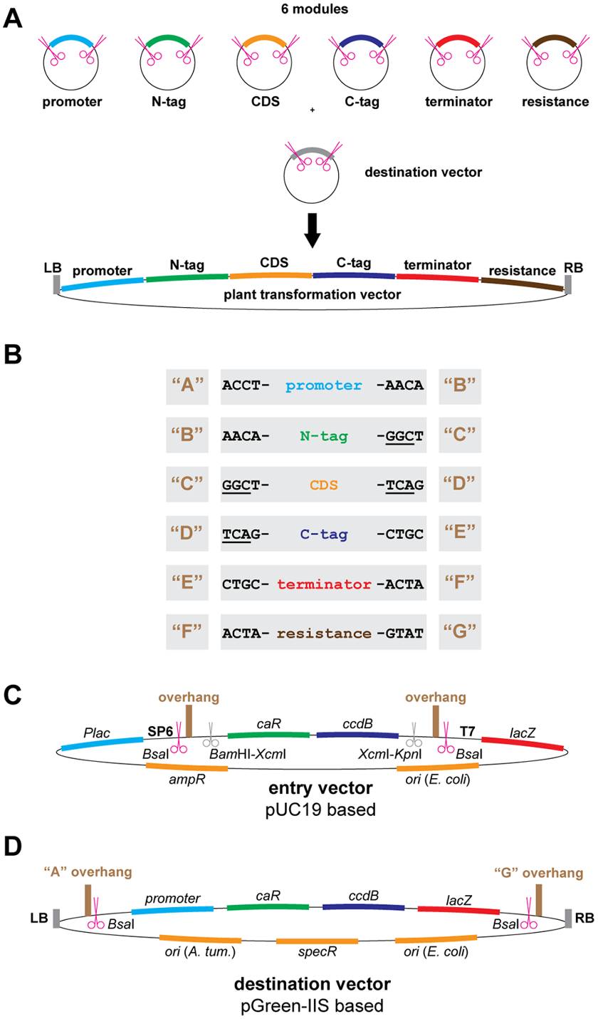
GreenGate vector design and layout. The GreenGate system six modules represent the plant promoter (1), an N-terminal tag (2), the coding sequence of the gene of interest (3), a C-terminal tag (4), the plant terminator (5) and the plant resistance cassette (6)

- GreenGate entry vector
  - The GreenGate cloning system uses six different types of pUC19 based entry vectors into which the individual elements are inserted
  - The multiple cloning site of pUC19 has been replaced by two BsaI recognition sites (magenta scissors), the respective overhangs for each module type, and a counter-selectable ccdB gene. DNA fragments can be cloned via the specific overhangs, via the BamHI and KpnI sites or via A-overhangs after XcmI digestion
- GreenGate destination vector
  - The GreenGate cloning system uses a pGreen-IIS based destination vector
  - The empty destination vector consists of a counter-selectable ccdB-cassette between the LB and RB sequences of pGreen-IIS, flanked by BsaI sites, with overhangs A and G.
  - Note: The pSa origin of replication (ori A. tum.) requires the presence of the helper plasmid pSOUP in agrobacteria

Making entry modules:
PCR is used to amplify the region of interest and add appropriate BsaI sites for cloning. The following sequences are added in front of the gene specific region of the F primer, and in front of the reverse complement of the gene specific region for the R primer.
F 5' AACAGGTCTCANNNN (nn) - Gene specific region -3'
GGTCTC is the BsaI recognition site; AACA was added because the enzyme does not cut if the restriction site is at the extreme ends of PCR products; NNNN represents the module specific overhang with the coding triplet being underlined; and 2 nucleotides (nn) are needed in case of the coding sequence and C-tag modules to bring the modules into frame

R 5'-AACAGGTCTCANNNN – Gene specific region reverse complement 3'
NNNN stands for the reverse complement of the module specific overhang, the coding triplet being underlined
PCR is conducted using standard protocols for high fidelity polymerase, and PCR product purified by gel extraction. Both PCR product and the corresponding entry module is digested with BsaI, and purified (PCR purification kit for PCR product, preferably gel extraction for entry module). Then the digested entry PCR product and the corresponding entry vectors are ligated.
The resulting entry vectors are then taken to the GreenGate reaction.

Greengate reaction
Set up the following in PCR tubes:
- 1.5 µl each entry vector 100 ng/µl
- 1 µl destination plasmid 100 ng/µl
- 1.5 µl cutsmart buffer
- 1.5 µl ATP 10 mM
- 1 µl T4 DNA ligase
- 1 µl BsaI-HF
- To 15 µl with H₂O
Cycle at 37 C for 2 mins and 16 C for 2 mins for 30 cycles, then 80 C for 5 mins. Transform 5 ul of the reaction into appropriate cells.

Multiple transcriptional units
Two transcriptional units
For two transcriptional units, two intermediate vectors, pGGM000 and pGGN000, and two adapter molecules are used. The final construct is created in two steps: First, the two transcriptional units are assembled separately in two parallel reactions into the intermediate vectors. The first of these two supermodules consists of a plant promoter, an N-terminal tag, a coding sequence, a C-terminal tag and a plant terminator. Furthermore, a pre-cloned adapter module with F and H overhangs is added to the reaction. The intermediate vector has BsaI recognition sites remaining in the vector backbone with matching A and H overhangs and confers resistance to kanamycin. The elements are combined in a GreenGate reaction but because two BsaI sites remain in the final construct, an additional ligation reaction is performed before transformation. The second supermodule is built similarly, but the adapter molecule has H and A overhangs and at the 39-end a plant resistance cassette is added. Thus, the resulting plasmid will have H and G overhangs. The two supermodules are then combined with the destination vector in a second step in a standard GreenGate reaction yielding the final construct.

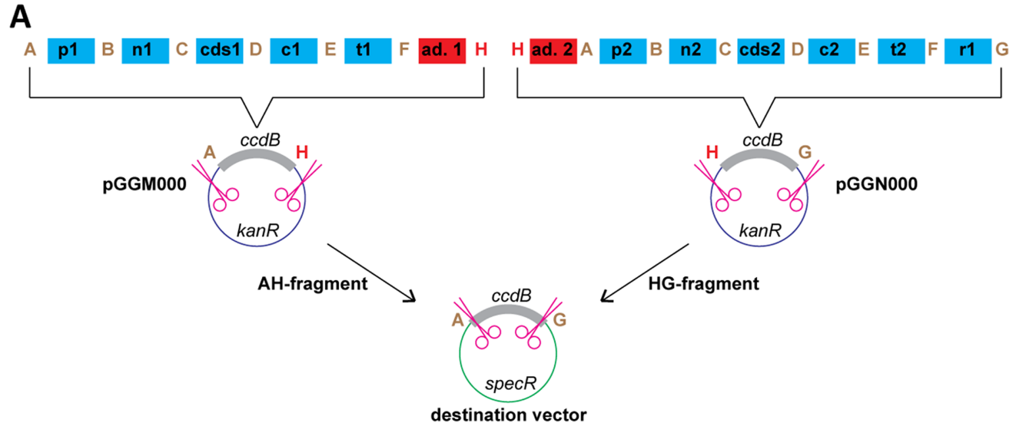

More than two transcriptional units
An additional module that is a synthetic DNA duplex with unpaired ends, allows ligation to H and G overhangs during a GreenGate reaction to make it possible to have two transcriptional units. It contains two internal BsaI recognition sites, which cannot be cut by BsaI due to overlapping cytosine methylation. Thus, the element will behave as an ordinary H to G module in the first GreenGate reaction and replace the resistance cassette.
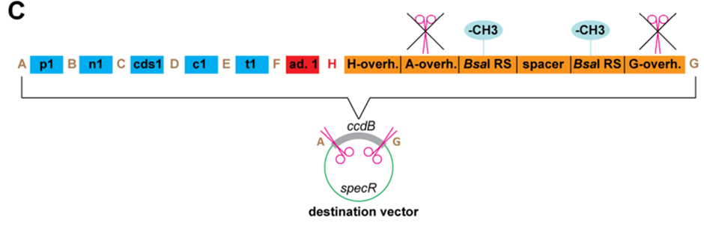
After transformation and miniprepping, this methylation will be lost as there are no dcm sites present in the oligo duplex. In a second round of GG reaction, the two internal BsaI recognition sites are now targets for BsaI, giving rise to A and G overhangs, simulating an empty destination vector.
Therefore, in each subsequent GreenGate round either the uncleavable oligo duplex can be used to prepare the plasmid for the insertion of another expression cassette or the plasmid can be finalized by adding a plant resistance cassette to the reaction. In this approach, the transcriptional units are assembled serially, so it requires one additional step for each expression cassette to be added.
The FHadapter used along with the oligo duplex separates the individual expression units in the final construct and thus can be freely designed to act as a spacer of arbitrary length and sequence minimizing the risk of mutual interference of the expression behavior.

Gibson cloning

Gibson primer design
Protocol Samuel Miller Lab
Gibson assembly primers are broken down in two parts: primer sequence and overlap sequence. The primer sequence should be designed using traditional characteristics in mind (i.e. Tm° values, G/C ratio, and G/C anchors). The overlap sequence needs to have between 20 – 150 bp homology to insert or vector. A good recommended start is a primer of 60 bp in total length: 30 bp of vector and 30 bp of insert.
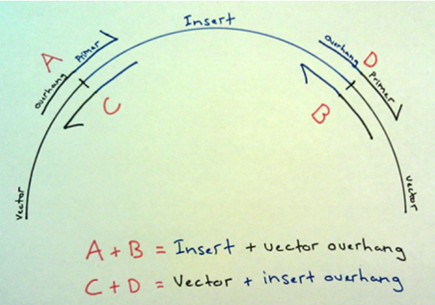
A: 5’ – (30 bp vector/ 30 bp insert) – 3’
and
D: 5’ – (30 bp insert/ 30 bp vector) – 3’
C: 3’ – (30 bp vector/ 30 bp insert) – 5’
and
B: 3’ – (30 bp insert/ 30 bp vector) – 5’

- PCR-amplify (see section PCR from DNA) the vector and insert using the right primer combination (A + B for insert and C + D for vector).
Note: If amplifying vector, digest with DpnI prior to Gibson assembly to remove parental vector.
Note: PCR or gel-clean-up is not required.

Gibson reaction
Reaction Stock Preparation
Prepare 5x ISO buffer: 6 mL of this buffer can be prepared by combining the following:
- 3 mL of 1 M Tris-HCl pH 7.5
- 150 μL of 2 M MgCl2
- 60 μL of 100 mM dGTP
- 60 μL of 100 mM dATP
- 60 μL of 100 mM dTTP
- 60 μL of 100 mM dCTP
- 300 μlL of 1 M DTT
- 1.5 g PEG-8000
- 300 μL of 100 mM NAD
- Add water to 6 ml
Aliquot in 100 μL aliquots and store at -20 °C.
Prepare master mixture. Combine the following:
- 320 μL 5x ISO buffer
- 0.64 μL of 10 U/μL T5 exonuclease
- 20 μL of 2 U/μL Phusion polymerase
- 160 μL of 40 U/μL Taq ligase
- Add water to 1.2 ml
Aliquot in 15 μL aliquots and store at -20 °C.
This assembly mixture can be stored at -20 °C for at least one year.
Reaction Procedure
- Thaw a 15 μL assembly mixture aliquot and keep on ice until ready to be used.
- Add 5 μL of PCR-amplified vector and insert DNA to be assembled to the master mixture.
Note: The DNA should be in equimolar amounts.
Total DNA to be assembled should range between 2 0- 200 ng.
For large DNA segments (> 150 kB): increased DNA amount should be used (e.g. 250 ng of each 150 kb DNA segment).
- Thoroughly mix gently.
- Incubate at 50 °C for 15 to 60 min.
- If cloning is desired, transform 1 – 5 μL to competent E. coli cell.
Note: Dialyze prior to electroporation. Heat-shock transformation can be done right so.
Gibson limitations and obstacles
A major limitation (especially in high GC-rich templates such as in P. aeruginosa) to Gibson assembly is that the termini of the DNA sequence fragments to be assembled, should not have stable single stranded DNA secondary structure, such as a hairpin or a stem loop, or repeated sequences, as this would directly compete with the required single-stranded annealing/priming of neighboring assembly fragments. So make sure to run your sequences in Scitools to look for such nuisance areas (Delta G for hairpins should be more than -10 and with a lower annealing temperature than that of primer:primer duplex).

Site directed mutagenesis (SDM)
Blunt end ligation-based SDM methods:
SDM using blunt end ligation results in a blunt end PCR product, which is circularized by ligation. First, primers are designed to incorporate the desired mutation (substitution, deletion or insertion). The plasmid to mutagenize is used as a template for PCR, and the resulting blunt end PCR product is ligated. Because the PCR product is missing the 5' phosphate, this needs to be added using a kinase. To avoid returning the original vector used as a template in the PCR, the sample should be digested using DpnI, which only cleaves methylated DNA and not the PCR product. Finally, the blunt end PCR product should be circularized using a ligase.
- Independent enzymes SDM
  - Perform PCR using a high-fidelity polymerase (Q5 or Phusion)
  - PCR clean PCR product
  - Set up DpnI (Fast digest Thermo FD1703) digestion on PCR product:
DNA | Up to 1 µg
10X FastDigest buffer | 2 µL
DpnI | 1 µL
Nuclease free H₂O | To 20 µL
  - Incubate 37 °C for 5 mins, inactivate at 80 C for 5 mins in a PCR machine.
  - Clean digested product with a PCR clean up column.
  - Set up the T4 polynucleotide kinase (NEB M0201) reaction:
DNA | Up to 300 pmol of 5’ termini*
T4 PNK Reaction Buffer 10X | 5 µL
ATP 10 mM | 5 µL
T4 PNK | 1 µL 10 units
Nuclease free H₂O | To 50 µL
* Use NEBioCalculator for calculating mass of DNA to add
moles of dsDNA ends = mass of dsDNA (g)/((length of dsDNA (bp) x 615.96 g/mol/bp) + 36.04 g/mol) x 2

The T4 PNK buffer can be substituted for T4 DNA ligase buffer. The 1X T4 DNA ligase buffer contains 1 mM ATP, so ATP does not need to be added. In this case, the product does not need to be cleaned before ligation, but supplemental ATP should be added to the kinase reaction to a final concentration of 1 mM.
  - Incubate at 37 °C for 30 minutes in PCR machine
  - Inactivate the reaction at 65 °C for 20 minutes
  - Clean product with a PCR clean up column
  - Set up T4 ligase (NEB M0202) ligation:
DNA | 1 µL of 50 ng
T4 Ligase Buffer 10X | 2 µL
T4 Ligase | 1 µL
Nuclease free H₂O | To 20 µL
  - Incubate at 16 °C overnight or at room temperature for 10 minutes.
    - The combination of 10 min at room temperature and 16 °C overnight is also possible
  - Heat inactivate at 65°C for 10 mins
  - Transform 1-5 µL into appropriate E. coli strain.

- Q5 site-directed mutagenesis kit (E0554S)
  - Primer should be designed with 5’ ends annealing back-to-back. It is recommended to use the NEB online design software (NEBaseChanger)
  - Perform a PCR using a high-fidelity polymerase (Q5 or Phusion)
PCR MasterMix:
 | 25µL / 12.5µL RXN | Final conc.
Q5 Hot Start High-Fidelity 2X MasterMix | 12.5µL / 6.25µL | 1X
10 µM Forward Primer | 1.25µL / 0.625µL | 0.5 µM
10 µM Reverse Primer | 1.25µL / 0.625µL | 0.5 µM
Template DNA (1-25 ng/µL) | 1 µL / 0.5µL | 1-25 ng
Nulcease-free water | 9µL / 4.5µL

Cycling conditions:
Step | Temperature | Time
Initial Denaturation | 98 °C | 30 sec
25 Cycles | 98 °C | 10 sec
25 Cycles | 50-72 °C* | 10-30 sec
25 Cycles | 72 °C | 20-30 sec/kb
Final Extension | 72 °C | 2 min
Hold | 4-10 °C
*For mutagenic primers, please use the Ta provided by the online NEB primer design software (NEBaseChanger)

  - Do a PCR clean-up using the kit
  - Set up the following KLD (Kinase, Ligase, DpnI) reaction on ice:
PCR product | 1 µL
2X KLD reaction buffer | 5 µL
10X KLD enzyme mix | 1 µL
Nuclease free H₂O | 3 µL
  - Mix well by pipetting up and down and incubate at room temperature for 5 minutes.
  - Transform 5 µL of KLD reaction to 50 µL appropriate competent cells.

Gibson-based SDM methods:
Gibson based SDM also requires designing primers incorporating the desired mutation, but the resulting PCR product should have complementary overlapping ends of 15-30 bp. Then an exonuclease chews back the 5' end, complementary regions anneal, DNA polymerase fills in the gaps within each annealed fragment, and ligase seals the nicks. The benefit of this approach is that it can also be used to assemble multiple fragments in one go.
- NEB HIFI (E2621)
  - Perform PCR using a high-fidelity polymerase (Q5 or Phusion)
  - PCR clean the PCR product
  - Set up the following reaction on ice:
Recommended Amount of Fragments Used for Assembly
 | 2–3 Fragment Assembly* | 4–6 Fragment Assembly**
Recommended DNA Molar Ratio | vector:insert = 1:2 | vector:insert = 1:1
Total Amount of Fragments | 0.03–0.2 pmols*  X μL | 0.2–0.5 pmols**  X μL
NEBuilder HiFi DNA Assembly Master Mix | 10 μL | 10 μL
Nuclease free H₂O | 10-X μL | 10-X μL
Total Volume | 20 μL✝✝ | 20 μL✝✝
* Optimized cloning efficiency is 50–100 ng of vector with 2-fold excess of each insert. Use 5-fold molar excess of any insert(s) less than 200 bp. Total volume of unpurified PCR fragments in the assembly reaction should not exceed 20 %. To achieve optimal assembly efficiency, design 15-20 bp overlap regions between each fragment.
** To achieve optimal assembly efficiency, design 20-30 bp overlap regions between each fragment with equimolarity of all fragments (suggested: 0.05 pmol each).
† Control reagents are provided for 5 experiments.
†† If greater numbers of fragments are assembled, increase the volume of the reaction, and use additional NEBuilder HiFi DNA Assembly Master Mix.
- Incubate samples in a thermocycler at 50 °C for 15 minutes (when 2 or 3 fragments are being assembled) or 60 minutes (when 4–6 fragments are being assembled).
- Store samples on ice or at –20 °C for subsequent transformation.
- Transform 2-5 uL of assembled product to appropriate cell strain.

Restriction enzyme-based SDM methods:
Restriction enzyme based SDM makes use of type II restriction enzymes (we have BsaI, AarI and BbsI). These enzymes cut outside of their recognition site, meaning cloning can be scar-free. Primers can be designed to introduce the appropriate mutation with internal restriction sites. This can be designed so that the recognition sites are cut out, leaving complementary sticky ends which are ligated. The benefit of this method is that multiple products can be ligated together, but it is best if there are no internal sites for the restriction enzymes which are used.
- Type II restriction enzyme mutagenesis
  - Perform PCR using a high-fidelity polymerase (Q5 or Phusion). Set up the following reaction:
 | 25µL / 12.5µL RXN | Final conc.
Q5 Hot Start High-Fidelity 2X MasterMix | 12.5µL / 6.25µL | 1X
10 µM Forward Primer | 1.25µL / 0.625µL | 0.5 µM
10 µM Reverse Primer | 1.25µL / 0.625µL | 0.5 µM
Template DNA (1-25 ng/µL) | 1 µL / 0.5µL | 1-25 ng
Nuclease-free water | 9µL / 4.5µL
  - Cycling conditions:
Step | Temperature | Time
Initial Denaturation | 98 °C | 30 sec
25 Cycles | 98 °C | 10 sec
25 Cycles | 50-72 °C* | 10-30 sec
25 Cycles | 72 °C | 20-30 sec/kb
Final Extension | 72 °C | 2 min
Hold | 4-10 °C
*For mutagenic primers, please use the Ta provided by the online NEB primer design software (NEBaseChanger)

  - PCR clean the PCR product
  - Digest PCR product with appropriate type II restriction enzyme and DpnI (to digest template DNA that is methylated). A typical restriction digest using ThermoFisherScientific restriction enzymes:
dH₂O | Up to 20 µL
10X Buffer* | 2 µL (1X)
DNA | Up to 1 µg
Restriction Enzyme (10 units) | 1 µL each
*If using Thermo AarI, be sure to add the 50X oligonucleotide mix as well as the buffer

  - PCR clean PCR product
  - Ligate using T4 DNA ligase
DNA | 1 µL of 50 ng
T4 Ligase Buffer 10X | 2 µL
T4 Ligase | 1 µL
Nuclease free H₂O | To 20 µL

  - Transform 1 µL of ligation to appropriate cells.

Escherichia coli transformation
Chemical transformation
- Defrost chemical competent E. coli cells on ice.
- Add 1-5 µL of DNA, mix by gently ticking the tube.
  - Do not vortex or pipet up and down!
  - A lower volume of DNA will cause a lower dilution/contamination risk.
- Incubate 30 minutes on ice
- Heat-shock cells for 45 seconds at 42 °C in a water bath, put back on ice.
  - If you use bought competent cells, reduce incubation time to 30 seconds.
- Add 950 µL LB medium
  - Alternatively, use SOC medium or low salt LB to increase efficiency.
- Incubate for 1 hour at 37 °C in a shaker.
- Plate 100 µL of the cells on LB agar plates supplemented with the respective antibiotics.
- Centrifuge cells at 3,000 x g for 2 minutes, discard supernatant besides of about 100 µL.
- Resuspend the pellet by gently vortexing or pipetting and plate left-over culture on LB agar plates supplemented with the respective antibiotics.
- Grow plates overnight at 37 °C.
- Check colonies the next day (they should not grow longer than max 24 h; these are false positives) and store plate at 4 °C.

Competent cells available in the lab:
- Depending on your plasmid of interest, choose between the following competent cells:
  - E. coli TOP10: F- mcrA (mrr-hsdRMS-mcrBC) 80lacZ M15 lacX74 recA1 ara 139 (ara-leu)7697 galU galK rpsL (StrR) endA1 nupG
    - Similar to DH5a, streptomycin resistant, engineered for high transformation efficiency of high-copy number plasmids
    - NOT suitable for empty vectors containing the ccdB gene
  - E. coli DB3.1: gyrA462 endA1 ∆(sr1-recA) mcrB mrr hsdS20 glnV44 (=supE44) ara14 galK2 lacY1 proA2 rpsL20 xyl5 leuB6 mtl1
    - Streptomycin resistant
    - ccdB resistant, so empty vectors can be transformed
  - E. coli BL21: fhuA2 [lon] ompT gal [dcm] ΔhsdS
    - Used for non-T7 expression
    - Suitable for transformation and protein expression

Agrobacterium tumefaciens transformation
Transformation of electrocompetent A. tumefaciens cells using electroporation:
- Prepare electroporation cuvettes: they are re-usable; make sure they have been disifected with ethanol, washed with dH20, dried and cooled at -20 °C before usage.
- Defrost electrocompetent A. tumefaciens cells on ice.
- Carefully add plasmid DNA (10-50 ng is sufficient)
Do not add more than 100 ng of DNA; otherwise, salts might cause a short circuit
- Carefully pipet A. tumefaciens and plasmid DNA mixture up and down for 1-2 times
- Transfer cell-plasmid-mixture into pre-cooled (on ice) electroporation cuvettes
- Wipe ice/any residual water from the cuvettes before transferring it into the electroporator
- Perform the electroporation using the electroporator from BioRad (located in the room on the 2nd floor with the laminar flows)
  - Electroporation settings:

- After performing the electroporation, directly add 1 mL of LB or SOC medium for recovering the bacteria and pipette in a new ep.
- Shake at 200 rpm at 28 °C for 2-4 hours.
- Plate cells onto selection plates (LB agar plus appropriate antibiotics encoded by the plasmid and rifampicin)
  - Spin cell cultures down for 2 min at 3000 x g, remove supernatant and dissolve pellet in residual culture and plate the remaining culture on a separate selection plate.
- Incubate the plates for 2-3 days at 28 °C.

Making competent cells
Heat-shock competent Top 10 E. coli cells:
Media:
250 mL 2x YT broth in 500 mL flask:
- 4 g Bacto tryptone
- 2.5 g Bacto yeast extract
- 1.25 g NaCl
- Water up to 250 mL
- PH to 7.0 with NaOH
- Autoclave
50 mL 1x YT broth:
- 0.4 g Bacto tryptone
- 0.25 g Bacto yeast extract
- 0.125 g NaCl
- Water up to 50 mL
- pH to 7.0 with NaOH
- Autoclave
TS buffer (TSB; prepare fresh on the day, when the competent cells are being made):
- 7.5 mL 2 x YT broth (final conc. 1X)
- 129 µL 5 M NaCl (final conc. 43 mM)
- 150 µL 1 M MgCl2 (final conc. 10 mM)
- 1.5 g polyethylene glycol (PEG) 4000 (final conc. 10 % (v/v))
- 750 µL DMSO (final conc. 5 % (v/v))
- 3 mL glycerol (final conc. 20 % (v/v))
- Water up to 15 mL
- Sterile filter the buffer and keep cool until needed
For all steps, work in a laminar flow to keep the cells sterile
Day 1:
- Streak bacteria on an antibiotic free LB plate (streak bacteria from stock; in this case Top 10 cells, but also works for other E. coli strains such as DB3.1 or BL21)
- Incubate the plate at 37 °C overnight
Day 2:
- Start an overnight culture in 4 mL YT broth and shake at 200 rpm and 37°C overnight
Day 3:
From here on, keep the cultures/cells always on ice
- Pre-cool big falcon centrifuge down to 4°C
- Transfer 2 mL of the primary overnight culture into each 500 mL flask with 200 mL room temperature 2x YT broth
- Shake at 200 rpm and 37 °C for about 2-3 hours until OD₆₀₀=0.3-0.6 is reached
- Divide secondary culture into four 50 mL tubes, centrifuge for 10 min at 3000 rpm at 4 °C and discard supernatant
- Resuspend the cells in 10 mL cold TSB (2.5 mL per falcon tube)
- Pool cells into a single falcon tube and incubate for 10 min on ice
- Aliquot 50 µL of the cells into pre-cooled 1.5 mL tubes (autoclaved beforehand) and freeze immediately in liquid nitrogen
- Store cells at –80°C until use
Test an aliquot of the untransformed competent cells for antibiotic resistance by plating on LB plates containing ampicillin (100 µg/mL working conc.) and kanamycin (50 µg/mL working conc.), respectively
Electrocompetent GV3101 Mp90 (pSoup-P19) Agrobacterium tumefaciens cells:
GV3101 Mp90 (pSoup-P19) from ZellBio:
https://zellbio.eu/product/gv3101-psoup-p19-agrobacterium-electrocompetent-cells/
For all the steps, work in a laminar flow to keep everything sterile
Day 1:
- Inoculate A. tumefaciens colony (derived from a freshly streaked LB plate containing the appropriate antibiotics) in 3 mL LB culture with antibiotics at 28°C and 200 rpm
(5 µg/mL rifampicin for A. tumefaciens in general, 30 µg/mL gentamycin and 5 µg/mL tetracyclin for pSoup-P19 helper plasmid)
Rifampicin needs to be dissolved in methanol or DMSO (precipitation occurs more frequently with methanol; do not store for several month)
Tetracyclin and Gentamycin can be dissolved in dH20; tetracyclin should be prepared freshly
Day 2:
- Inoculate 150 mL LB with antibiotics with 2 mL of the overnight culture
- Incubate at 28°C at 200 rpm until OD₆₀₀ reaches 0.8-1.0
Start in the morning if you can clearly see that the 3 mL culture has grown; otherwise, wait till the evening
Day 3:
- Pre-cool falcon centrifuge to 4°C
- When the cultures reached the desired OD₆₀₀, chill cultures for 15 min on ice and swirl regularly
From here on, everything needs to happen on ice or at 4°C!
- Distribute culture into 3x50 mL tubes and pellet by centrifugation at 4000 x g for 20 min at 4°C
- Discard supernatant and resuspend each pellet in 10 mL ice cold dH20 (autoclaved beforehand)
- Combine the 3 tubes into 2 tubes and further adjust volume to 50 mL each with ice cold dH20
Vortex each falcon with 10 mL ice cold dH20, mix it and top up to 50 mL
- Pellet cells by centrifugation at 4000 x g for 20 min at 4°C
- Discard supernatant and resuspend each pellet in 10 mL ice cold dH20
- Combine the 2 tubes into 1 tube and further adjust to 50 mL with ice cold dH20 as described before
- Pellet cells by centrifugation at 4000 x g for 20 min at 4°C
- Discard supernatant and resuspend pellet in 1.5 mL ice cold 10 % (v/v) glycerol (autoclaved beforehand)
- Dispense 50 µL aliquots into pre-cooled 1.5 mL tubes (autoclaved beforehand) and flash freeze in liquid nitrogen
- Store aliquots at -80°C until use

Colony PCR
Colony PCRs can be used as an initial test to confirm success of the cloning approach before inoculating the transformants in liquid culture. For this, select a region for not more than 1 kb that you want to amplify. The primers that you use for amplifying the region of interest should be insert- and vector-specific (e.g. forward primer binds within the insert, reverse primer binds in the vector backbone).
Depending on the number of colonies you want to test, prepare a master mix with the ThermoScientific DreamTaq Green PCR Master Mix (2X).
It is not necessary to prepare reaction volumes of up to 50 µL (according to the manufacturer's instructions), one quarter of the reaction volume (12.5 uL) is sufficient
Always prepare a master mix for 1 reaction in excess
MasterMix for colony PCR:
DreamTaq Green PCR Master Mix (2X)* | 6.25 µL
Forward primer (10 µM stock conc.) | 0.625 µL (0.5 µM final conc.)
Reverse primer (10 µM stock conc.) | 0.625 µL (0.5 µM final conc.)
MilliQ water | Up to 12.5 µL
*no need to use a high fidelity polymerase (TAQ is sufficient)
Adding material of the bacterial colonies into the PCR vials containing the PCR mixture:
- Aliquot the PCR mixture into PCR vials and transfer those into the laminar flow
- Touch the bacterial colony with a sterile tip and transfer it into the PCR vials; gently pipette up and down to resuspend the bacteria in the PCR mixture
It is not necessary to visually see bacteria on the pipette tip, it is sufficient to gently touch the colony
Tip: Streak the colonies you want to test on a “Master” plate before adding it to the PCR mixture; then, you have more material for later inoculations and can organize them more carefully
- Spin down the PCR reaction mixture and start the PCR in a thermo cycler
PCR settings:
- Perform the PCR according to the manufacturer's instructions, to the length of the fragment you want to amplify and the annealing temperature of the primers
- 30 cycles are enough for colony PCRs; otherwise, you may proliferate artificial products
- E. coli colony PCRs: for initial denaturation step at 98 °C for 3 min
- A. tumefaciens colony PCRs: for initial denaturation step at 98 °C for 10 min
After performing the PCR reaction in a thermo cycler, run the PCR in on a 1 % agarose gel together with a 1 kB DNA ladder. Afterwards, visualize the DNA bands with UV light. If the DNA bands are in accordance with the expected fragment size, you can inoculate the bacterial colony into LB medium with the respective antibiotic for further downstream processing (e.g. plasmid prep).

Sequencing (Sanger)
The results of our cloning approaches can be verified by Sanger Sequencing. We are sending our samples to LGC Genomics (https://shop.lgcgenomics.com/). Results can be analyzed using Geneious.
Step 1: Prepare your samples in 1.5 mL reaction tubes
- Template requirements:
Plasmids |  | 100 ng/µL
PCR products | 200 - 500 bp | 10 ng/µL
 | 500 - 1,000 bp | 20 ng/µL
 | 1,000 - 2,000 bp | 40 ng/µL
- FlexiRun: 40 µL of template DNA
- Ready2Run: Pre-pipetted primer (10 µL DNA + 5 µL primer [5 µM])
- In room 00.34, you will find a cardboard box with LGC prepaid labels and envelopes
- Place one label per tube, collect all tubes in an envelope and put it together with the waybill number (secretary's office) in the LGC plastic box in the entrance of Biosystems II
Step 2: Place your order at LGC (https://shop.lgcgenomics.com/)
- At “sequencing ordering”, you will find below “single sample” the option for “Ready2 / Flexi Run”
- Enter your sample label ID, sample name and the service you want to use (Ready2 / Flexi Run)
  - In case you chose Flexi Run, indicate which primer should be used by LGC
- Continue with filling in the information for the pick-up box and your e-mail address on the next site, and confirm the order
- Schedule the pick-up with DHL until 12:00 via https://mydhl.express.dhl/be/en/schedule-pickup.html#/schedule-pickup#label-reference
- Results will be available in about 2-3 working days (notification via e-mail) and can be downloaded at "Data Management – Order&Download Results”
Step 3: Analyze your sequences with Geneious
- Book working station in advance via clustermarket
- Import .ab1 files to geneious, check sequence quality at the beginning and end of the sequence before aligning with your GOI

Antibiotics
- Prepare stock solutions of each antibiotic according to the desired concentration
- Filter-sterilize in the laminar flow and aliquot into 1.5 mL tubes
- Store at -20°C until use (keep lifetime of certain antibiotics in mind!)
For solid plates: Add antibiotics to the medium only, if it is hand-warm or cooler!
Antibiotic | Stock concentration | Working concentration
Ampicillin | 100 mg/mL | 100 µg/mL
Carbenicillin  (alternative to ampicillin) | 100 mg/mL | 100 µg/mL
Chloramphenicol | 25 mg/mL (dissolved in EtOH) | 25 µg/mL
Kanamycin | 50 mg/mL | 50 µg/mL
Spectinomycin | 50 mg/mL | 50 µg/mL
Gentamycin | 50 mg/mL | 30 µg/mL
Tetracycline | 10 mg/mL | 10 µg/mL
Rifampicin | 50 mg/mL (dissolved in DMSO or MeOH) | 5-20 µg/mL
Cefotaxime | 100 mg/mL | 100 µg/mL

